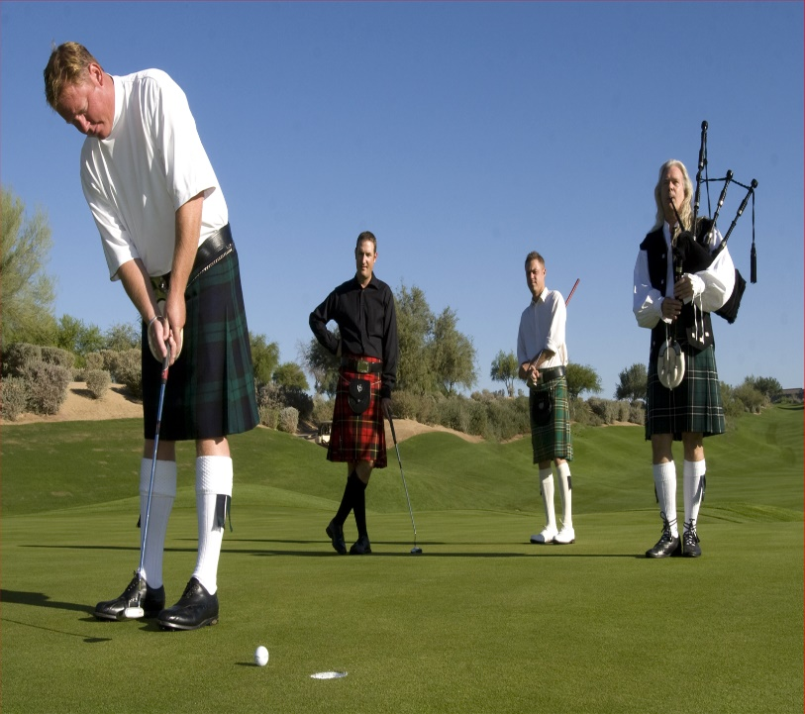
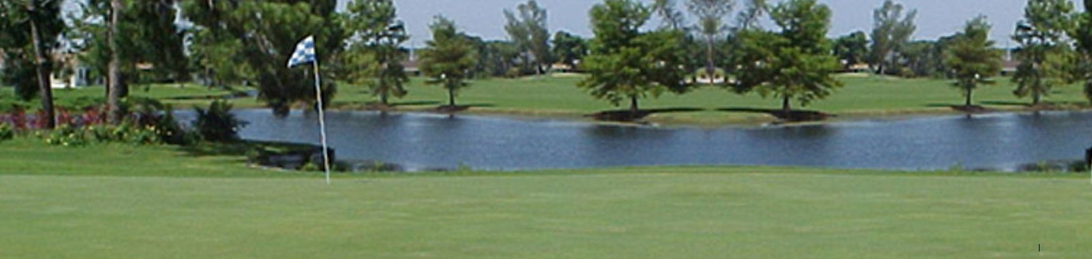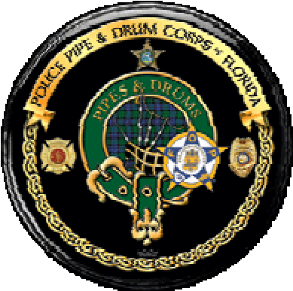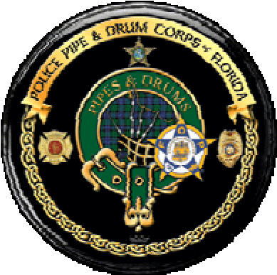
Police Pipe and Drum Corps of Florida

6th ANNUAL GOLF TOURNAMENT
June 6th, 2026
Tee time is 8 AM
$175.00 per golfer
Play in teams of 4
Single golfers welcome
Price After May 31st $180 Per golfer
Plantation Preserve
7050 W Broward Blvd
Plantation, Florida, 33317



Contact Dave to register at 305-481-3873 or www.policepipebandflorida.org
This is a scramble tournament. All skill levels are welcome. Kilts are not required.

Lunch • Swag Bags • Prizes • Free Beer
Raffles • Bagpipers • Trophies • & More
Wear Your Kilt for 1 Stroke off your team total!
Sponsorship Opportunities for Your Business
Gain valuable advertising by sponsoring a hole, tee, green or putting green starting at $150.
Includes a sign on the course & inclusion in print advertising, where appropriate.
Or provide golfer goodies for our Swag Bags with your company name.

Contact Dave or Renee Campbell at 954-848-9954 or fppb2016@gmail.com

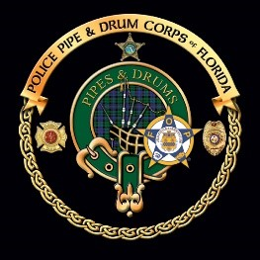
To Whom It May Concern,

The Police Pipe and Drum Corps is preparing for its 6th Annual Golf Tournament; a fundraising event to be held at the Plantation Preserve Golf Course June 6th, 2026. We would like to take this opportunity to invite you to sponsor a hole or donate a prize for our event raffle.

The rate to sponsor a tee box is $150.00. Sponsoring a green is $250.00. (If you have a
preference, you may request a specific hole for your sponsorship) The Police Pipe and Drum Corps is a 501(c)3 certified non-profit organization, so all donations will receive a receipt to verify tax-deductible donations upon request.

Custom designed Sponsor signs will be posted at the site, acknowledging each patron of the tournament. Just provide a scan of your logo in one of the following formats: .jpg, .pdf or vector file, and we'll do the rest. Given the already-strong interest, participation is expected to be very good, enabling Sponsor signs to enjoy high visibility among both golfers and observers alike.

All Sponsors and Prize Donors will also be included in the promotional materials at the golf course and acknowledged during the luncheon. And if you provide a banner, we'll be happy to display it during the event.

We would also like to extend an invitation to you and/or your employees to play in this fun and worthy event. Cost of participation is $175 per person or $700 per foursome. After May 31st $180 per person.

For more information on sponsoring a hole or donating a prize for our raffle, please contact us at the number or email address listed below, or visit our website at:

www.policepipebandflorida.org

Thank you for your consideration.

Dave & Renee Campbell
305-481-3873
fppb2016@gmail.com

Please make checks payable to:
Police Pipe and Drum Corps of Florida • 1301 SW 66th Terrace •
Plantation, Florida, 33317 305-481-3873

Police Pipe and Drum Corps of Florida

6th Annual Police Pipe
Band Golf Tournament
June 6^{th,} 2026,
Tee Time: 8:00 AM

HOST COURSE
Plantation Preserve
7050 W Broward Blvd.
Plantation, FL 33317
Ph.: 954-848-9954
ENTRY INCLUDES
FREE BEER on the Course

EVENT CONTACT

Dave or Renee Campbell
954-848-9954 or
fppb2016@gmail.com

TOURNAMENT PLAY
$175.00 per golfer/$700.00 per foursome
Scramble format. All skill levels welcome.
After May 31st $180 per golfer

SPONSORSHIP

$150 Hole: Tee Box

$250 Green: Putting Green
* Quality logo image required for production of sponsor signage and related advertising.

ENTRY FORM &

Swag Bags, Trophies & Raffles SPONSORSHIP DETAILS
Bloody Mary’s, or Mimosa’s, www.policepipebandflorida.org Bagels, and Donuts, or contact Dave at fppb2016@gmail.com
Lunch with CASH BAR

GOLFER NAMES (Please Print Clearly) CONTACT PHONE E-MAIL

- ____________________________________________________________________________________________________________
2. ____________________________________________________________________________________________________________

3____________________________________________________________________________________________________________

4____________________________________________________________________________________________________________

TEAM NAME _________________________________ (MUST BE PROVIDED)

Make Checks Payable To: Police Pipe & Drum Corps of Florida
Or highlight and copy this link to pay via our Square Account
https://square.link/u/CqC43f8I

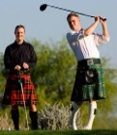
Police Pipe and Drum Corps of Florida
Golf Scramble Sponsorship Form
Tournament Date June 6th, 2026

Prize Donation ______________ Your Gift to the Band
Suggestions: Golf Balls, Club, Bag, Golfers Hand Towels, etc....

Hole _________________________ $150.00
We will produce a sign using a quality file that you supply to place on the course at the edge of the Tee Box

Putting Green __________________ $250.00
We will produce a sign using a quality file that you supply to place on the course at the edge of the putting green.

Longest Drive __________________ $300.00
We will produce a sign using a quality file that you supply to place on the fairway where the longest drive is to take place.

Closest to The Pin _______________$300.00
We will produce a sign using a quality file that you supply to place near the hole where the closest to pin drive is to take place.

Beer Cart Sponsor _____________$500.00 each (2 available)
We will produce a sign using a quality file that you supply to place on the Beer Golf Cart.

Hole In One Sponsor____________$1000.00
Donator will pay for all costs relating to this event, the prize board will list their name as the sponsor.

Merchandise Sponsor___________$1,400.00
Sponsor the Golf Tournament Shirt, Towels, Hats, have your business logo along with band logo on the item

Breakfast ______________________$2,000.00
There may be only one Exclusive Breakfast Sponsor. First Come First Served. We will produce a banner to be displayed at breakfast using a quality file that you supply. One Complimentary Foursome will be given.

Award Ceremony ________________$2,600.00
There may be only one Exclusive Award Ceremony Sponsor. First Come First Served. We will produce a banner to be displayed at the award ceremony using a quality file that you supply. One complimentary foursome will be given.

Luncheon ______________________$4,500.00
There may be only one Exclusive Luncheon Sponsor. First Come First Served.
We will produce a banner using a quality file that you supply to display at the luncheon ceremony. We will produce three signs using a quality file that you supply. The signs will be placed at the holes, greens, or fairways of your choice. One complimentary foursome will be given.

Event Sponsor__________________ $6,000.00
There may be only one Event Sponsor. First Come First Served.
We will produce three banners using a quality file that you supply to display on the course and luncheon for the awards ceremony. We will produce four signs using a quality file that you supply. The signs will be placed at the holes, greens, or fairways of your choice. One complimentary foursome will be given.

***** All artwork must of a Quality JPG File for proper submission to the printer*****

Sponsors of all categories listed above will be included in the sponsor listing on our event website. If desired by the sponsor, we will include a logo and link to the sponsor’s website. Sponsors and prize donors will also be advertised in the promotional materials at the golf course. If you provide a banner, we will be happy to display it during the event.

Checks for sponsorship should be made payable to: Police Pipe and Drum Corps of Florida, and mailed to:1301 SW 66th Terrace, Plantation, FL. 33317 Deadline for Receipt of sponsorship information and materials needed for production of signs and banners is May 22nd, 2026.

For additional information contact Dave or Renee Campbell at 305-481-3873 or via email at fppb2016@gmail.com
Police Pipe and Drum Corps of Florida
Golf Scramble Sponsorship Form
Tournament Date June 6th, 2026
Tee Time 8:00 AM

Sponsor Name

Contact Name

Sponsor Address
s

t
Suite / Ap

Cit
y

State
Contact Phon
e

email address
URL for website lin
k

Sponsor Level
Quantity

Amount

Totals

File names:

ge)
for course signa
(
(
)
for banner signage

(
For sponsor web page
)

I have emailed the files to fppb2016@gmail.com on: _______________________________________
I have hand-delivered the files to: _______________________________________________________
Sponsored advertisements for this event will appear on the Police Pipe and Drum Corps website after the event and remain for twelve months or until the next similar event.
I (we) will be putting ________ complimentary golfers in the tournament as part of my sponsorship.
I have read page one, and I am aware of deadlines and requirements. I have the authority to sign below.
Print Name: ______________________________________
Signature: _______________________________________ Date: ____________
Make checks payable to: POLICE PIPE AND DRUM CORPS OF FLORIDA
(POLICE PIPE AND DRUM CORPS OF FLORIDA INC is a 501(c)3 certified organization and can provide tax receipts for sponsorship donations if requested.)
Please send completed Sponsorship form with payment to: POLICE PIPE AND DRUM CORPS OF FLORIDA
1301 SW 66th Terrace
Plantation, FL 33317

